**EXPERIMENT – 1**

**TO PERFORM FOLLOWING LINUX COMMANDS**

1. **To create and remove directory**
2. **To create file and delete file**
3. **File copy and moving**
4. **Listing of files with various options**
5. **Aim: - To create and remove directory**

**Procedure:**

1. **Creation**

Syntax:

mkdir <directory_name>

Example:

mkdir my_directory

1. **Deletion**

Syntax:

rmdir <directory_name>

Example:

rmdir my_directory

1. **Aim: - To create file and delete file**

**Procedure:**

1. **File Creation**

Syntax:

cat > <file_name>

// File content

Example:

cat > file.txt

Hello World!

CTRL + D (save file)

1. **File Deletion**

Syntax:

rm <file_name>

Example:

rm my_file.txt

1. **Aim: - File copy and moving**

**Procedure:**

1. **Copy file**

Syntax:

cp <source_file> <new_file_name>

Example:

cp file.txt file2.txt

1. **Moving file**

Syntax:

mv <source_file> <destination_path >

Example:

mv file.txt /user/my_directory/

1. **Aim: - Listing of files with various options**

**Procedure:**

1. Basic listing files and directories

Command:

ls

Output:

file1.txt file2.txt subdirectory

1. Show all files included hidden files and directories

Command:

ls –a

Output:

. .. file1.txt file2.txt .hidden_file subdirectory

1. Show detailed information about files and directories

Command:

ls –l

Output:

total 12

-rw-r--r-- 1 user group 1024 Jan 1 10:00 file1.txt

-rw-r--r-- 1 user group 2048 Jan 1 11:30 file2.txt

drwxr-xr-x 2 user group 4096 Jan 1 09:45 subdirectory

**Result: -** Commands executed successfully.

**EXPERIMENT - 2**

**TO PERFORM FOLLOWING HADOOP COMMANDS**

1. **Directory creation or deletion**
2. **Putting file from local to Hadoop**
3. **Listing the file with various options**
4. **File copy and moving**
5. **Aim:- Directory creation and deletion**

**Procedure:**

1. **Creation**

Syntax:

hadoop fs -mkdir <directory_path>

Example:

hadoop fs -mkdir /user/myuser/new_directory

1. **Deletion**

Syntax:

hadoop fs -rmdir <directory_path>

Example:

hadoop fs -rmdir /user/myuser/new_directory

1. **Aim:- Putting file from local to Hadoop**

**Procedure:**

Syntax:

hadoop fs -put <local_file_path> <hdfs_destination_path>

Example:

hadoop fs -put /path/to/local/file.txt /user/myuser/hdfs_directory/file.txt

1. **Aim:- Listing the file with various options**

**Procedure:**

1. **Basic listing of files in a directory:**

Syntax:

hadoop fs -ls /user/myuser/hdfs_directory

Output:

Found 3 items

-rw-r--r-- 3 user supergroup 1234567890 2024-01-08 10:00 /user/myuser/hdfs_directory/file1.txt

-rw-r--r-- 3 user supergroup 9876543210 2024-01-07 15:30 /user/myuser/hdfs_directory/file2.txt

drwxr-xr-x - user supergroup 0 2024-01-06 09:45 /user/myuser/hdfs_directory/subdirectory

1. **Long format listing with human readable sizes:**

Syntax:

hadoop fs -ls -l -h /user/myuser/hdfs_directory

Output:

Found 3 items

-rw-r--r-- 3 user supergroup 1.1G 2024-01-08 10:00 /user/myuser/hdfs_directory/file1.txt

-rw-r--r-- 3 user supergroup 9.2G 2024-01-07 15:30 /user/myuser/hdfs_directory/file2.txt

drwxr-xr-x - user supergroup 0 2024-01-06 09:45 /user/myuser/hdfs_directory/subdirectory

1. **Recursive listing of files and subdirectories:**

Syntax:

hadoop fs -ls -R /user/myuser/hdfs_directory

Output:

/user/myuser/hdfs_directory/file1.txt

/user/myuser/hdfs_directory/file2.txt

/user/myuser/hdfs_directory/subdirectory:

drwxr-xr-x - user supergroup 0 2024-01-06 09:45 /user/myuser/hdfs_directory/subdirectory/inner_directory

-rw-r--r-- 3 user supergroup 456 2024-01-05 12:00 /user/myuser/hdfs_directory/subdirectory/inner_file.txt

1. **Aim:- File copy and moving**

**Procedure:**

1. **File Copy**

Syntax:

hadoop fs -cp <source_path> <destination_path>

Example:

hadoop fs -cp /user/myuser/source_directory/file.txt /user/myuser/destination_directory/file.txt

1. **File Moving**

Syntax:

hadoop fs -mv <source_path> <destination_path>

Example:

hadoop fs -mv /user/myuser/source_directory/file.txt /user/myuser/destination_directory/new_file_name.txt

**Result:** Hadoop commands executed successfully.

**EXPERIMENT – 3**

**TO PERFORM THE MONGODB QURIES AND TASK**

1. **Create a database using MongoDB**
2. **Create a collection**
3. **Insert a document into collection**
4. **Display document**
5. **Deletion of document from collection**
6. **Updating of document**
7. **Aim: - Create a database using MongoDB**

**Procedure:**

Syntax:

use <database name>

Example:

use my_db

Output:

mongodb> switched to db my_db

my_db> {ok:1}

1. **Aim: - Create a collection**

**Procedure:**

Syntax:

db.createCollection(“<collection name>”)

Example:

db.createCollection(“Students”)

show collection

Output:

my_db> Students

1. **Aim: - Insert document into collection**

**Procedure:**

Syntax:

db.Students.insertMany([{“Reg No”:’01’, “Name”:’Rahul’,”Age”:’34’},

{“Reg No”:’02’, “Name”:’Rohit’,”Age”:’19’},

{“Reg No”:’03’, “Name”:’Amit’,”Age”:’24’}])

Example:

my_db> … … … {

Acknowledged : true,

insertedIds : {

‘0’ : ObjectId(“934782392h3id9dun23r92389f8ajh”),

‘1’ : ObjectId(“934782392sfisfosii6n23r92389f8ajh”),

‘2’ : ObjectId(“79283798423hjskdfsnfwefw89fwfui”)

}

}

1. **Aim: - Display document**

**Procedure:**

Syntax:

db.<collection name>.find()

Example:

db.Students.find()

Output:

my_db> [

{

_id : ObjectId(“934782392h3id9dun23r92389f8ajh”),

“Reg No”:’01’,

“Name”:’Rahul’,

”Age”:’34’

},

{

_id : ObjectId(“934782392sfisfosii6n23r92389f8ajh”),

“Reg No”:’02’,

“Name”:’Rohit’,

”Age”:’19’

},

{

_id : ObjectId(“79283798423hjskdfsnfwefw89fwfui”),

“Reg No”:’03’,

“Name”:’Amit’,

”Age”:’24’

}

]

1. **Aim: - Deletion of document from collection**

**Procedure:**

Syntax:

db.<collection name>.remove(deletion criteria)

Example:

db.Students.remove({“Reg No”:”03”})

db.Students.find()

Output:

my_db> [

{

_id : ObjectId(“934782392h3id9dun23r92389f8ajh”),

“Reg No”:’01’,

“Name”:’Rahul’,

”Age”:’34’

},

{

_id : ObjectId(“934782392sfisfosii6n23r92389f8ajh”),

“Reg No”:’02’,

“Name”:’Rohit’,

”Age”:’19’

}

]

1. **Aim: - Updating of document**

**Procedure:**

Syntax:

db.<collection name>.update(criteria, updated_data)

Example:

db.Students.update({“Reg No” : ”02”}, {$set : {“age” : “21”}})

db.Students.find()

Output:

my_db> [

{

_id : ObjectId(“934782392h3id9dun23r92389f8ajh”),

“Reg No”:’01’,

“Name”:’Rahul’,

”Age”:’34’

},

{

_id : ObjectId(“934782392sfisfosii6n23r92389f8ajh”),

“Reg No”:’02’,

“Name”:’Rohit’,

”Age”:’21’

}

]

**Result: -** MongoDB commands executed successfully.

**EXPERIMENT – 4**

**WRITE A PROGRAM IN PYTHON TO PERFORM BASIC OPERATION ON IMAGES**

1. **Display image**
2. **Display resized image**
3. **Display grayscale image**
4. **Display flipped image**
5. **Aim:- Display Image**

**Procedure:**

import cv2

img = cv2.imread('dog.jpeg')

cv2.imshow("Dog Image",img)

cv2.waitKey()

cv2.destroyAllWindows()

**Input:**

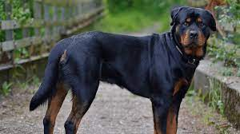

**Output:**

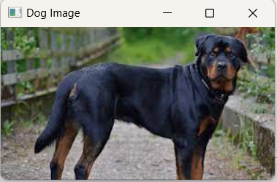

1. **Aim:- Display resized image**

**Procedure:**

import cv2

img = cv2.imread('dog.jpeg')

resize_img = cv2.resize(img,(200,200))

cv2.imshow("Dog Resized Image",resize_img)

cv2.waitKey()

cv2.destroyAllWindows()

**Input:**



**Output:**

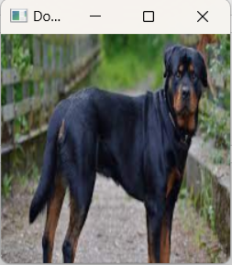

1. **Aim:- Display grayscale image**

**Procedure:**

import cv2

img = cv2.imread('dog.jpeg')

gray_img = cv2.cvtColor(img,cv2.COLOR_BGR2GRAY)

cv2.imshow("Dog Gray Image",gray_img)

cv2.waitKey()

cv2.destroyAllWindows()

**Input:**



**Output:**

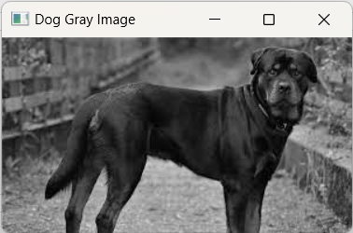

1. **Aim:- Display flip image**

**Procedure:**

import cv2

img = cv2.imread('dog.jpeg')

flip_img = cv2.flip(img,0)

cv2.imshow("Flipped Image",flip_img)

cv2.waitKey()

cv2.destroyAllWindows()

**Input:**



**Output:**

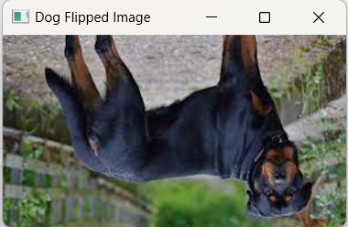

**Result:** Successfully performed basic operations on image.

**EXPERIMENT – 5**

**WRITE A PROGRAM TO COUNT THE FREQUENCY OF WORDS IN A GIVEN PARAGRAPH OR SENTENCE**

**Aim: -** The aim of this program is to count the frequency of words in a text.

**Procedure:**

def word_freq(sent):

counts = dict()

words = sent.split()

for word in words:

if word in counts:

counts[word] += 1

else:

counts[word] = 1

return counts

text = str(input('Enter the sentence:'))

print(word_freq(text.lower()))

**Input:**

Enter the sentence:This is a python program. this IS A Python code.

**Output:**

{'this': 2, 'is': 2, 'a': 2, 'python': 2, 'program.': 1, 'code.': 1}

**Result: -** We successfully executed the frequency counts program.

**EXPERIMENT – 6**

**WRITE A PROGRAM IN PYTHON TO PERFORM AUDIO SIGNAL PROCESSING**

**Aim: -** The aim of this program is to perform Audio signal processing using python.

**Procedure:**

from pydub import AudioSegment

# import the audio file

wav_file = AudioSegment.from_file(file="sample-6s.wav",format="wav")

# data type for the file

print(type(wav_file))

#  To find frame rate of song/file

print(wav_file.frame_rate)

print(wav_file.channels)

print(wav_file.sample_width)

print(wav_file.max)

print(len(wav_file))

wav_file_new = wav_file.set_frame_rate(50)

print(wav_file_new.frame_rate)

**Output:**

<class 'pydub.audio_segment.AudioSegment'>

44100

2

2

22298

6391

50

**Result: -** We successfully executed the audio file signal processing.

**EXPERIMENT – 7**

**WRITE A PROGRAM IN PYTHON TO PERFORM VIDEO SIGNAL PROCESSING**

**Aim: -** The aim of this program is to perform video signal processing using python opencv library.

**Procedure:**

# importing libraries

import cv2

import numpy as np

# Create a VideoCapture object and read from input file

cap = cv2.VideoCapture('sample-5s.mp4')

# Check if camera opened successfully

if (cap.isOpened()== False):

print("Error opening video file")

# Read until video is completed

while(cap.isOpened()):

# Capture frame-by-frame

ret, frame = cap.read()

if ret == True:

# Display the resulting frame

cv2_imshow(frame)

# Press Q on keyboard to exit

if cv2.waitKey(25) & 0xFF == ord("q"):

break

# Break the loop

else:

break

# When everything done, release # the video capture object

cap.release()

# Closes all the frames

cv2.destroyAllWindows()

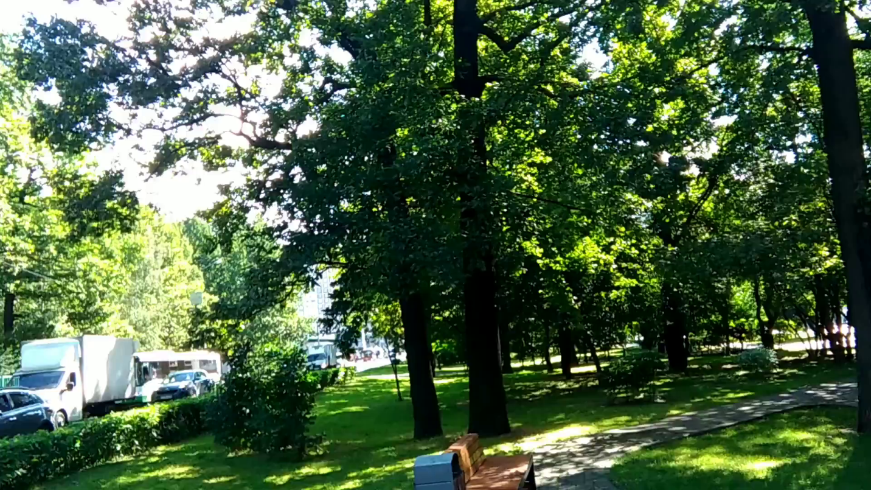**Output:**

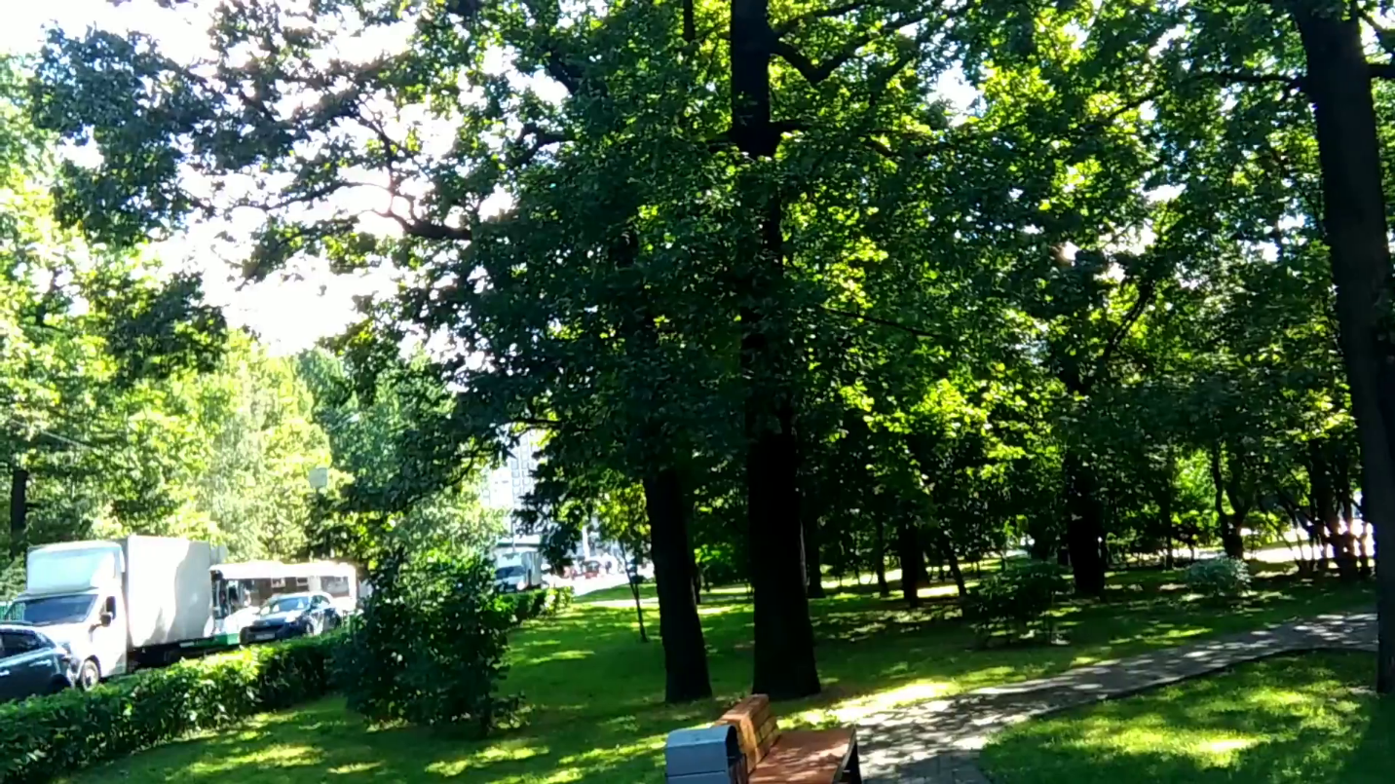

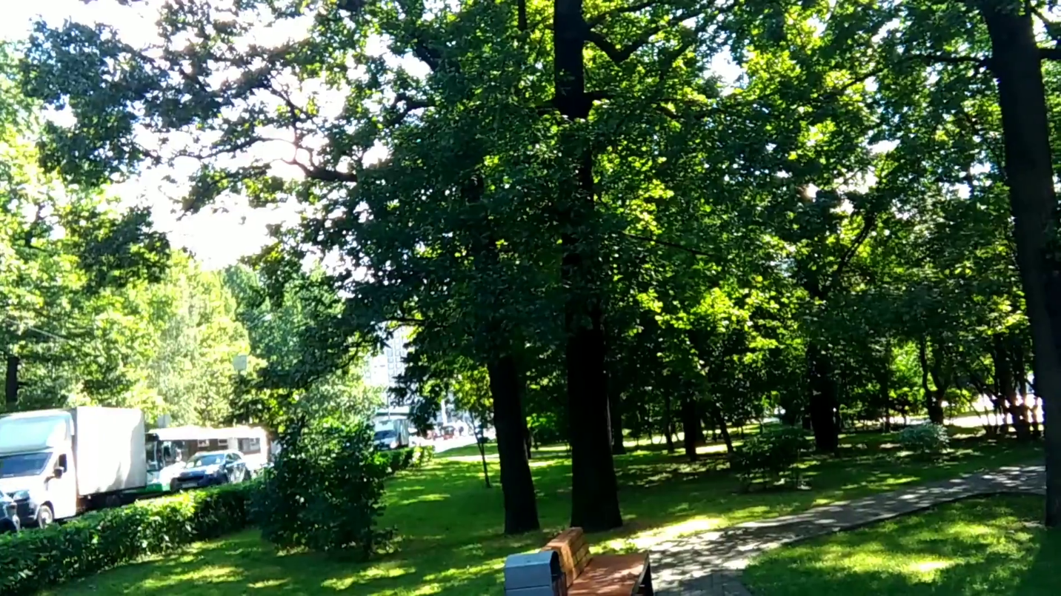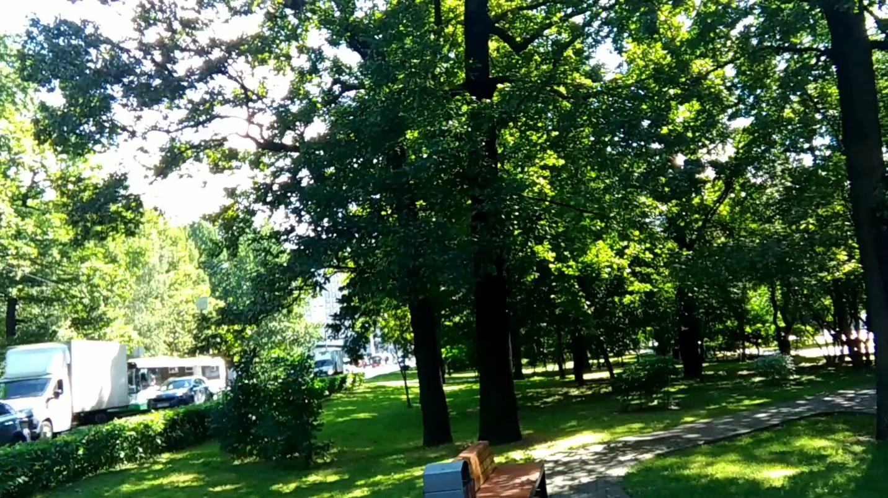

**Result: -** We successfully executed video signal processing program.

**EXPERIMENT – 8**

**WRITE A PROGRA, THAT DEMONSTRATE CREATION OF RDD FROM TEXT FILE**

**Aim: -** The aim of this program is the creation of rdd from txt file using pyspark.

**Procedure:**

import findspark

findspark.init()

from pyspark import SparkContext

from pyspark.sql import SparkSession

spark = SparkSession.builder.master('local').appName('Exercise').getOrCreate()

rdd = spark.sparkContext.textFile('sample.txt')

print(rdd.take(2))

**Output:**

['Hello World!', 'This is a PySpark Program.']

**Result: -** We successfully created an rdd from text file.

**EXPERIMENT – 9**

**WRITE A PROGRA, THAT DEMONSTRATE CREATION OF RDD FROM CSV FILE**

**Aim: -** The aim of this program is the creation of rdd from csv file using pyspark.

**Procedure:**

import findspark

findspark.init()

from pyspark.sql import SparkSession

spark = SparkSession.builder.master('local').appName('CSV_FILE').getOrCreate()

rdd = spark.sparkContext.textFile('Sample.csv')

print(rdd.take(2))

**Output:**

['1,"Eldon Base for stackable storage shelf, platinum",Muhammed MacIntyre,3,-213.25,38.94,35,Nunavut,Storage & Organization,0.8', '2,"1.7 Cubic Foot Compact ""Cube"" Office Refrigerators",Barry French,293,457.81,208.16,68.02,Nunavut,Appliances,0.58']

**Result: -** We successfully created an rdd from csv file.

**EXPERIMENT – 10**

**CREATE A PYSPARK PROGRAM THAT READ THE TEXT FILE AND PERFORM A WORD COUNT ON THE CONTENTS**

**Aim: -** The aim of this program is to read the text file and perform a word count on the contents.

**Procedure:**

import findspark

findspark.init()

from pyspark import SparkContext

from pyspark.sql import SparkSession

spark = SparkSession.builder.master('local').appName('Exercise').getOrCreate()

rdd = spark.sparkContext.textFile('sample.txt')

word_counts = rdd.flatMap(lambda line: line.split(" ")) \

.map(lambda word: (word, 1)) \

.reduceByKey(lambda a, b: a + b)

for word, count in word_counts.collect():

print(f"{word}: {count}")

**Output:**

Data: 2

Science: 2

Interview,: 1

Hello: 1

Sir,: 1

I: 2

am: 2

a: 2

coder: 1

and: 1

Hello,: 1

Student: 1

**Result: -** We successfully executed program to read text file and perform word count.

**EXPERIMENT – 11**

**WRITE A PROGRAM IS TO DEMONSTRATE CREATION OF DATAFRAME FROM LIST**

**Aim: -** The aim of this program is to demonstrate creation of dataframe from list.

**Procedure:**

import findspark

findspark.init()

from pyspark.sql import SparkSession

spark = SparkSession.builder.getOrCreate()

data = [('001','Rahul','India'),('004','Ajay','India'),('003','Anuj','USA')]

col = ['Reg No.','Name','Country']

df = spark.createDataFrame(data,schema=col)

df.show()

**Output:**

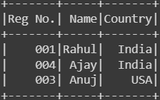

**Result: -** We successfully created dataframe from list.

**EXPERIMENT – 12**

**WRITE A PROGRAM THAT DEMONSTRATES CREATION OF DATAFRAME FROM CSV FILE**

**Aim: -** The aim of this program is to create a dataframe from csv file.

**Procedure:**

import findspark

findspark.init()

from pyspark.sql import SparkSession

spark = SparkSession.builder.getOrCreate()

df_csv = spark.read.csv('Sample.csv',header='true',inferSchema='true')

df_csv.show()

**Output:**

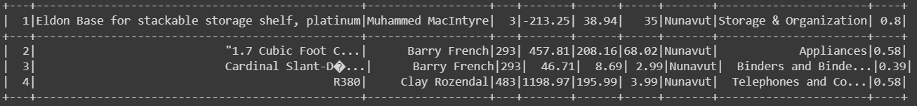

**Result: -** We successfully created a dataframe from csv file.

**EXPERIMENT – 13**

**WRITE A PROGRAM THAT DEMONSTRATE THE USE OF ORDERBY( ) AND SORT ( ) FUNCTION.**

**Aim: -** The aim of this program is to demonstrate the use of orderBy() and sort() function.

**Procedure:**

import findspark

findspark.init()

from pyspark.sql import SparkSession

spark = SparkSession.builder.getOrCreate()

data = [('001','Rahul','India'),('004','Ajay','India'),('003','Piyush','USA'),('002','Sanjay','USA'),('005','Krish','UK')]

col = ['Reg No.','Name','Country']

df = spark.createDataFrame(data,schema=col)

# by using orderBy()

df.orderBy('Name','Country').show()

# by using sort()

df.sort('Country').show()

**Output:**

Output of orderBy() function

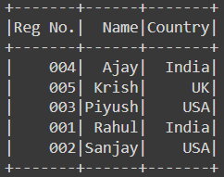

Output of sort() function

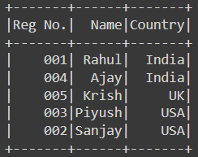

**Result: -** We successfully demonstrate the use of orderBy() and sort() function on dataframe.

**EXPERIMENT – 14**

**WRITE A PROGRAM THAT DEMONSTRATE THE USE OF GROUPBY ( ) FUNCTION.**

**Aim: -** The aim of this program is to demonstrate the use of groupBy() function.

**Procedure:**

import findspark

findspark.init()

from pyspark.sql import SparkSession

spark = SparkSession.builder.getOrCreate()

data = [('Rohit','India',4000),('Rahul','India',3897),('Amit','USA',2569),('Sanjay','USA',3678),('Anmol','UK',3781),('Anuj','UK',1781)]

col = ['Emp_Name','Country','Salary']

df = spark.createDataFrame(data,schema=col)

df.groupBy('Country').agg({'Salary': 'mean'}).collect()

**Output:**

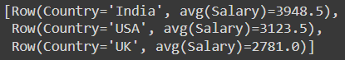

**Result: -** We successfully demonstrate the use of groupBy() function on dataframe.

**EXPERIMENT – 15**

**WRITE A PROGRAM THAT DEMONSTRATE THE USE OF JOIN ( ) FUNCTION.**

**Aim: -** The aim of this program is to demonstrate the use of join() function.

**Procedure:**

import findspark

findspark.init()

from pyspark.sql import SparkSession

from pyspark.sql.functions import desc

spark = SparkSession.builder.getOrCreate()

data = [('Rohit','India',4000),('Rahul','India',3897),('Amit','USA',2569),('Sanjay','USA',3678),('Anmol','UK',3781),('Anuj','UK',1781)]

col = ['Emp_Name','Country','Salary']

# first dataframe

df = spark.createDataFrame(data,schema=col)

data2 = [('Rohit','India',34),('Rahul','India',64),('Amit','USA',20),('Sanjay','USA',None),('Anmol','UK',39),('Anuj','UK',45)]

col2 = ['Emp_Name','Country','Age']

# second dataframe

df2 = spark.createDataFrame(data2,schema=col2)

df.join(df2, 'Emp_Name', 'inner').select('Emp_Name','Salary', 'Age').sort(desc("Age")).collect()

**Output:**

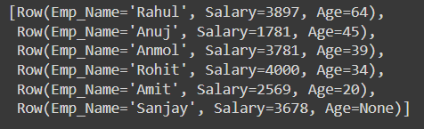

**Result: -** We successfully demonstrate the use of join() function on two dataframes.

**EXPERIMENT – 16**

**WRITE A PROGRAM THAT DEMONSTRATE THE USE OF TRANSFORM ( ) FUNCTION.**

**Aim: -** The aim of this program is to demonstrate the use of transform() function.

**Procedure:**

from pyspark.sql import SparkSession

from pyspark.sql.functions import col

spark = SparkSession.builder.appName("transformExample").getOrCreate()

# Create a sample DataFrame

data = [("James", "Sales", 3000),

("Michael", "Sales", 4600),

("Robert", "Sales", 4100),

("Maria", "Finance", 3000),

("James", "Sales", 3000)]

columns= ["employee_name", "department", "salary"]

df = spark.createDataFrame(data = data, schema = columns)

print("Original DataFrame:")

df.show()

def transform_salary(df):

return df.withColumn("salary", col("salary") * 2)

df_transformed = df.transform(transform_salary)

print("Transformed DataFrame:")

df_transformed.show()

**Output:**

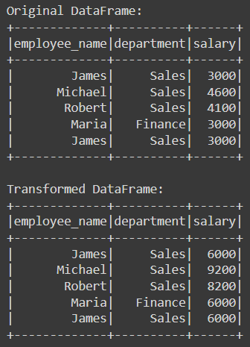

**Result: -** We successfully demonstrate the transform() function on dataframe.